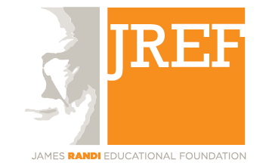
Grants for Educators 2011

The James Randi Educational Foundation’s grants
for educators are intended to help offset the cost of developing and improving critical thinking and scientific skepticism programs for K-12 students. Grants are awarded to K-12 educators for projects that promote critical thinking through the examination of the paranormal and pseudoscience. Grants are not limited to traditional classroom teachers, and those from other educational institutions such as museums, camps, and community centers are encouraged to apply.

These grants are supported by the JREF’s members. To help support this program, donate here: http://www.randi.org/site/support-us

Grants will help educators:

- Purchase materials and equipment for the classroom, school, or community.
- Begin new outreach and educational programs focused on skepticism and critical thinking.
- Enhance and expand existing skepticism and critical thinking educational programs.
- Attend courses, workshops, or conferences related to scientific skepticism that will substantially contribute to their teaching activities.

The JREF will award a limited number of grants of up to $500 each. Educators selected to receive grants are those whose are deemed to:

- Have the greatest need.
- Have submitted detailed proposals describing how the grant money will be spent.
- Be likely to have the most significant and widest impact with their proposed activities.

We ask that curricula and other resources developed with the help of this grant be made available to other educators through the James Randi Educational Foundation.

Proposals must be received by July 1, 2011 to be eligible for 2011 grants. Please complete the form on the following page and email it to education@randi.org.

2011 JREF Grants for Educators Application

Name
Email
Phone
Your title or position
School or institution name
Institution type | - K-12 school  - Museum  - Camp  - Community Center  - Other: ___________________
Age of students for proposed program
Number of students
Are you requesting support for an existing program or a new one? | - This is to support an existing program  - This is for development of a new program
Amount requested | US $
Program description

Describe your project in detail. Include information about project start and completion date, activities, budget, and ways it will promote critical thinking and raise awareness about topics related to pseudoscience and the paranormal.

Is there any additional information you would like to provide about you or your project?

